Karewa ISLAND Race
IRON OR CHANGEOVER

Karewa, is a small, 3.57 ha, predator free wildlife sanctuary in the Bay of Plenty which sits 6 km off Matakana Island and is administered by the Department of Conservation, with Ngāti Ranginui as a Tuatara Reserve. Its main species are tuatara and flesh-footed shearwaters. The legend of Taurikura relates how the tuatara on Karewa are descended from a chief's errant daughter.

Date: Saturday 29 January 2022
Cost: $40 per paddler
Distance: Approximately 33km
Tides: High Tide – 5.04am Low Tide – 11.10am
Iron Start: 10:30am
Changes Start: 11.30am
(Note: Those who wish to do a change-over race must supply their own support boat.
Covid: My Vaccination passes are required, scanning in mandatory and Masks must be worn on land.
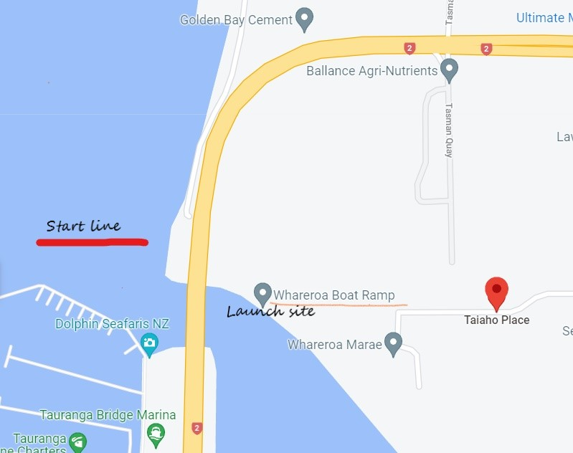
Venue: Whareroa boat ramp, Taiaho Place, Tauranga, Bay of Plenty

Race Course
1. Start outside Tauranga bridge marina, launch from Whareroa boat ramp.
2. Proceed up Tauranga Harbour towards the Harbour entrance keeping to the right-hand side of the shipping channel
3. First change just after Tangaroa (Statue at the entrance of Tauranga Harbour)
This is the first and last change point, no changes up to this point and no changes after this point on the way back.
4. Karewa Island is located NNW from the Harbour entrance, crews may plot their best course to Karewa island rounding anti-clock wise around the island, with a beach finish next to Whareroa Wharf.
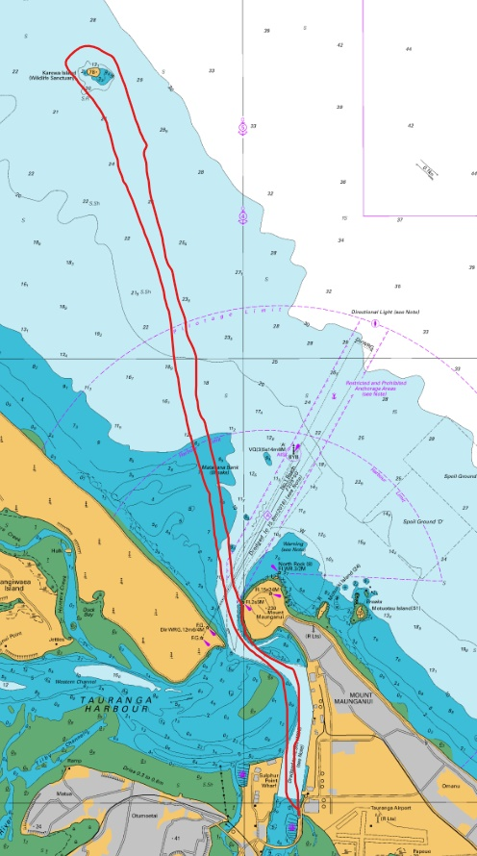

Safety Equipment:
- Spray skirts must be fitted and in full operational condition.
- Two spare paddles, two bailers, 1 flare, tow rope fitted, handheld VHF radio, 6 life jackets, spare lashing.
- Hydration system for each paddler
- This is an open ocean race and conditions can change rapidly.
- The tidal currents at the entrance to Tauranga Harbour can be very strong with steep waves in the central channel area.
- The port of Tauranga is the busiest in NZ. Container/Log/Fuel Ships have right of way.
- Tugs and the Yellow Pilot boat can create large wakes
- All contestants should familiarize themselves with NKOA long distance race/safety rules.
- Beware of exposed sandbanks at race start, and returning to the Harbour at mid tide.

Contact:
Mike Hickson 027 284 0658
Email: hoearohawhanau@gmail.com

